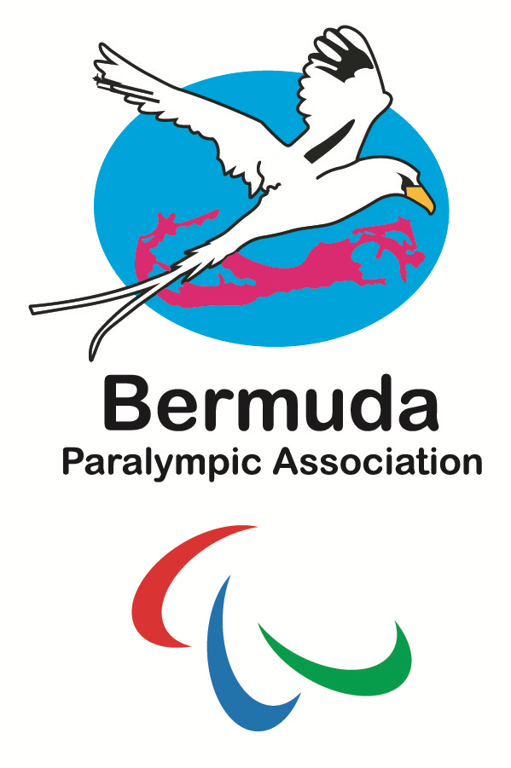
Bermuda Paralympic Association
Suite 1148, 11 Bermudiana Rd.
Pembroke HM 08, Bermuda
bermudaparalympic@gmail.com

March 20, 2026

Ms. Jada Richards
Admin Assistant to Sr. Sports Development Officer
Department of Youth, Sport & Recreation
8 Wesley Street
Hamilton HM 11

Attention: Ms. Richards

This letter is to endorse Jessica Lewis’ application for the Elite Athlete Sponsorship 2026.

Miss Lewis has represented Bermuda at the elite level of Para-Sport in every Parapan American Games, World Championships and Paralympic Games since her debut in the Guadalajara 2011.

The Bermuda Paralympic Association funds the major para-sport festivals but in order to qualify Miss Lewis has to find the resources to attend many international events annually.

She is especially deserving of this sponsorship because, as the Department realizes, para-athletes to date do not qualify for Elite Athlete Funding (Government funds) administered by the Bermuda Olympic Association.

Miss Lewis has won medals for Bermuda at World Championships and the Parapan Am Games (2015, 2019 & 2023). In 2024 Jessica broke the American Regional record for a T53 Female in the 100m which had stood for 27 years!

The Bermuda Paralympic Association highly supports Miss Lewis’ application.

Sincerely yours,
Ann Lindroth
President, Bermuda Paralympic Association

